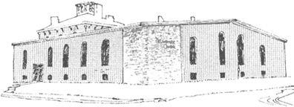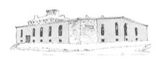

****

Pastor James Reynolds, Sr.

Asst. Pastor Stephen G. Reynolds, Sr.

1008 Congress St. Portland, ME 04102

Tel. (207) 774-8192

[www.**thedeliverancecenter**.com](http://www.thedeliverancecenter.com)

*From the Desk of Pastor Stephen Reynolds, Sr.*

Dear , Brother Will Myette:

I am so thankful for your love and respect for me, in working together at the Deliverance Center with all the men. It is a new day we all are facing just before the end-time Deliverance for the Overcomer. It will take having; like precious faith, the unity of the Spirit and absolute surrender to the Lord to accomplish the tasks that the Lord has for us all to finish.

Faithfulness as good Stewards is what we are endeavoring to demonstrate to all, at all times, in all things. Our Mission involves **M**ercy **i**n **s**trong **s**tewardship **i**n **o**rganizing **n**aturally.

In the Morning Feb. 12,2010 while we are joined together after devotion you can give a briefing on what is to be done on the regular daily chores, laundry, and kitchen schedule, cooking and clean-up.

* (We need to give special attention to helping them apply their cleaning skills to their own bedrooms. Just keep a close watch on keeping things in their right places).

Written Requests for leaving property must be received through written Permission.

Phone call notice only for emergencies, Absolutely NO requests for the hall or stairwell.

Things to ask:

1. Do you know how to demonstrate your faithfulness to the Lord?
   1. Through your faithfulness to those God put you under.
2. What type of person has the bigger problem?
   1. People that complain instead of written explanation.
3. Who becomes faithful in much?
   1. Luke 16:10 **He that is faithful in that which is least** is faithful also in much: and **he that is unjust in the least** is unjust also in much.
4. Who becomes unjust in much?
   1. **“he that is unjust in the least”**

In Service for the King:

Sincerely,

Stephen G. Reynolds, Sr.

Assistant Pastor